MADISON EMERGENCY SERVICES ASSOCIATION, Inc.
2019 ANNUAL COMMUNITY REPORT

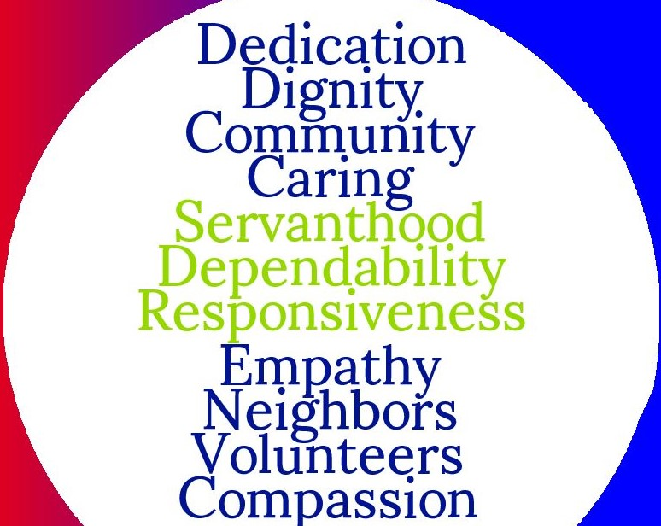

APRIL 2020

April 2020

Hello Neighbors & Friends,
Madison Emergency Services Association, Inc. (MESA) is excited to show you the impact our programs and services have been able to support in Madison County in 2019. This is our first Annual Report, and it inaugurates the next chapter in MESA’s long and fruitful history.
MESA strives to be a resource for our Madison County neighbors in times of need and when unexpected emergencies happen. Throughout the past year, MESA distributed food to 3,705 households; provided timely and needed personal and monetary help to 754 individuals; ensured that a safe and stable living environment was provided for 7 adults and 14 children who lived at Barbara’s House; and collected, sorted and sold hundreds of donated goods that supported MESA’s mission and our emergency fund.
It is an honor to be able to help the number of people we do each year during their time of need, but nothing we do would be possible without the dedication and commitment of our volunteers, donors, partners, and staff who work tirelessly. We are deeply grateful for your support.
On behalf of those we serve, thank you for your gifts of time, talent, and money to support MESA.

Sincerely,
John Eleanor
John Huelskoetter Eleanor Mower
President, Board of Directors Executive Director

Introduction
The Madison Emergency Services Association (MESA) has existed since 1982. Over the last 38 years, MESA has provided safety-net services to countless numbers of Madison County neighbors and friends. Services provided include a food pantry, Thrift Shop, Barbara’s House, and emergency monetary assistance through our Client Services group. MESA has grown from humble beginnings to become a mainstay of support for Madisonians in need. It has grown because of the extraordinary gifts of volunteer time and monetary donations of a large number of people who reside here. This is our first Annual Report and it inaugurates the next chapter in MESA’s long and fruitful history. We are providing this Report in response to questions about how people’s donations are being utilized by MESA, and to celebrate all that the people of Madison County make possible each year. On behalf of the Executive Director, members of the Board, staff, and especially our dedicated volunteers and donors, we say a hearty thank you!
Food Pantry
The Madison Emergency Services Association (MESA) food pantry is open between 9.5 to 10 hours a week (Tuesday, Wednesday, Thursday, and Friday) to serve those in need of food in our community. In 2019, one full-time staff member, supported by many dedicated volunteer pantry helpers and food pick-up drivers, devoted hundreds of hours receiving, sorting, and storing 86,225 pounds of food.
The pantry strives to offer healthy options like low-sugar, low-sodium canned goods and cereals. Fresh produce and eggs are received from local farmers and from larger chain food stores in the area. However, the largest and most consistent donations come from local churches and community members. MESA benefits from several food drives coordinated by the U.S. Postal service, local schools, and others in the community.
The food pantry provides personal hygiene products such as toilet paper, toothpaste, deodorant, and diapers, which are not available for purchase with food stamps.
During the summer, the pantry offers bag lunches to school-aged children that normally receive free breakfast and lunch at school. Since the program began, MESA has given out over 1,800 summer lunches.
MESA partners with the Blue Ridge Area Food Bank and the U.S. Department of Agriculture (USDA) Emergency Food Assistance Program (TEFAP).
In 2019, MESA’s Food Pantry served 6,385 individuals and 2,830 households:
Individuals Households
Yearly Totals 6,385 2,830
Monthly Averages 532 236

In 2019, MESA’s USDA Food Distribution Program served 2,049 individuals and 875 households:
Individuals Households
Yearly Totals 2,079 875
Monthly Averages 171 73
Emergency Services
MESA provides emergency services to assist those in need. No appointment is necessary; a Client Intake Manager is on site Tuesday and Thursday from 10am-3pm to meet with patrons to understand their need for support and or for temporary emergency relief. MESA offers a wide variety of assistance, such as monetary support, information and referral, supportive guidance, and family programs.
In 2019, MESA gave 754 individuals help and assistance with:
- utility payments.
- rent/mortgage payments.
- personal needs.
- referrals to other service providers.
- transportation needs (gas, car repairs, car insurance).
- school supplies.
- diapers for children.
- clothes for the family.
- medical and dental needs.
Barbara’s House
Barbara’s House (BH) is named after longtime MESA treasurer Barbara Sherman and has been a residential transitional housing program for families in need since October 2002. The house was planned and built through grant money, donations, and the extraordinary effort of community volunteers.
Since BH first opened its doors, it has helped over 100 families—not only in providing transitional housing, but while these families lived at Barbara’s House, they received help in finding employment, received counseling on nutrition and health issues, and guidance on money management and parenting.
BH is maintained and run through a program called Families-In-Transition (FIT). Only those who agree to participate in the FIT program are permitted to live in the residence.
BH provides families or individuals a safe and secure place to reorganize their lives, offering a large (over 3000 sq. ft) building that is divided into five (5) apartments, with an onsite playground. BH offers two (2) three-bedroom furnished units, and three (3) two-bedroom furnished units. Families can stay rent-free for up to a year, while volunteer mentors help and guide them through whatever life issues and challenges, they have.
In 2019, 7 adults and 14 children lived at Barbara’s House.

Thrift Shop
MESA’s Thrift Shop is open to all and sells used goods—clothing, books, music, housewares, videos, collectibles, and furniture—donated by members of the public. Revenue from the Thrift Shop (more than $40,000 in 2019) annually supports both our client services and emergency relief fund.
The Thrift Shop is opened 9am to 5pm on Tuesday, Wednesday, and Thursday, and 9am to 2pm on the 2nd and 4th Saturdays of each month. The Thrift Shop is managed by one full-time manager and a part-time assistant who receive and sort on a weekly basis, approximately 10-15 boxes of home goods, 10-12 large bags of clothes, and many furniture items. Critical assistance is provided by dedicated volunteers who in 2019 gave 1,794 hours of volunteer time and assistance to MESA’s Thrift Shop.

FINANCIAL SUMMARY
Fiscal Year Ended December 31, 2019

REVENUE AND SUPPORT
Gifts and support $ 230,783
Donated food $ 35,901
Contributions $ 194,882

Other revenue $ 62,026
Grants $ 9,000
Other $ 53,026

TOTAL REVENUE $ 292,809

EXPENSES

Program services $ 176,920
Fundraising $ 2,902
Management and general $ 77,890

TOTAL EXPENSES $ 257,712

NOTES:
Revenues: Revenues were $292,809 or $58,009 better than the budget. The higher revenue is the result of a large individual gift and two very successful campaigns: end-of-year and Give Local Piedmont.
Expenses: 2019 expenses of $257,712 are $21,388 lower than the budget.
Surplus/(Deficit): MESA ended the year with a surplus versus the projected deficit.
Bank Accounts: MESA has three (3) bank accounts with a total current cash balance of $152,200.
Mortgage: Current mortgage balance is $456,351.20. Interest paid in 2019 was $12,758.55. The mortgage payment is $19,981, due each September.

2019 MESA Board of Directors
John Huelskoetter, President
Dan Albrant, Vice President
Norris John, Treasurer
Jeannine Utz, Secretary
Jerry Butler, Director
Janice Carpenter, Director
Dink Kreis, Director
Gerald Monnat, Director
John Storey, Director
Katherine Thomas, Director

TEFAP distributes federally supplied commodities such as canned and frozen food to eligible households. Eligibility in this program is based on recipient income; distribution is limited to one time per month per family. On the second Saturday of every month, MESA provides USDA food to its eligible recipients at Beth Car Baptist Church in Madison, VA.
Donations, sales
Fundraising events, rents
Includes yearly mortgage cost

